Geochronology Helper Excel Add-in Guide

Author: Jarred C Lloyd ([jarred.lloyd@adelaide.edu.au](mailto:jarred.lloyd@adelaide.edu.au) / [jarredclloyd@gmail.com](mailto:jarredclloyd@gmail.com))

Version: 2.5.0

Description: This excel add-in is designed to aid with preparation of laser ablation U–Pb, Rb–Sr, and Lu–Hf geochronology and elemental data, and sulphur isotope data from LADR for further statistical analysis. Additional functionality is built in for arrangement of U­–Pb data from GLITTER, data sorting and cleaning, and pre-processing of Re–Os, Lu–Hf and Rb–Sr QQQ files for use in LADR and iolite.

URLs: <https://github.com/jarredclloyd/VBA_GeochronHelper_xlam>

<https://universityofadelaide.box.com/v/GeochronHelperXlam>

Contents

1 Changelog for this version (v2.5.0) 2

2 Installation of add-in 3

3 LADR geochronology output arrangers 5

3.1 Secondary standard corrections 7

4 LADR S isotope arranger 8

5 LADR Elemental arranger 8

6 Re–Os (QQQ pre-processing for iolite) 8

7 GLITTER functionality 8

8 Utilities 9

8.1 Individual column sorter and text Clean 9

8.2 LADR error correlation workaround 9

9 References 10

# Changelog for this version (v2.5.0)

* Fixed procedure call for LADR elemental CSV button
* Added element total column to outputs
* Added capabilty to dynamically handle element symbol number ordering (as opposed to NumSym)
* Adjusted renumbering mask to handle "Sample - trailingNum" and "Sample-trailingNum" formats
* Adjusted elemental arranger and U–Pb to handle NewWave generic numbering
* Added CPS cols for Rb-Sr and Lu–Hf arrangers
* Updated headers to be machine friendly - does not apply to mass shifted elemental headers
* Revised U—Pb arranger to be more streamlined for easier maintenance and lessen code duplication
* Updated element number-symbol order check

# Installation of add-in

Copy the “Geochron Helper VX-Y-Z.xlam” to a local folder of your choosing.

The default add-in location for Microsoft Office is %AppData%/Microsoft/AddIns although you can access the add-in from any local location. I do however suggest placing the add-in in the XLSTART location (next paragraph) as this will ensure correct loading of the add-in and UI each time you open excel.

Due to the way Excel 2016 and above handle add-in security, the downloaded version of the add-in may not load correctly or at all. The easiest and safest (I’ve not written any malicious code here) workaround is to place the add-in into a trusted folder. My suggested location is the XLSTART folder. For this location copy the following into the address bar of windows explorer: **%AppData%\Microsoft\Excel\XLSTART**This will load the add-in on Excel start.

If you do not have admin access you cannot get to this point. Look for another trusted folder to place it into, otherwise you may need to temporarily enable all macros and/or disable protected view (not recommended). A list of *trusted locations* can be found in the *Trust Centre*. You can also add to the trusted locations and adjust the macro and protected view settings here.

* File → Options → Trust Centre → Trust Centre Settings…

To enable the add-in, first open Excel:

* Then either
  + File → Options → Add-ins → Manage → Excel Add-ins → Go → Browse

Or if you have the *Developer* Tab enabled on the ribbon

* + Developer > Excel Add-ins > Browse

The other suggested location is**:  
%AppData%/Microsoft/AddIns**You will have to manually enable the add-in from within Excel.

* Navigate to the folder containing “Geochron Helper VX-Y-Z.xlam” and select it
* Enable the add-in by ticking the checkbox and pressing the OK button
* 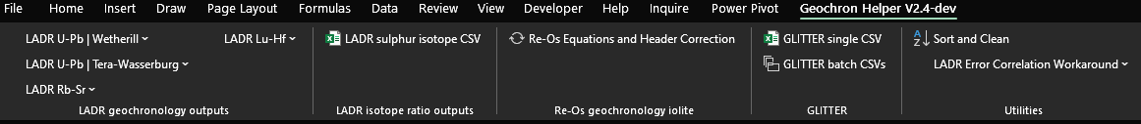The add-in should show in the ribbon as the last tab with the name and version

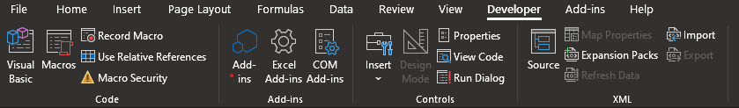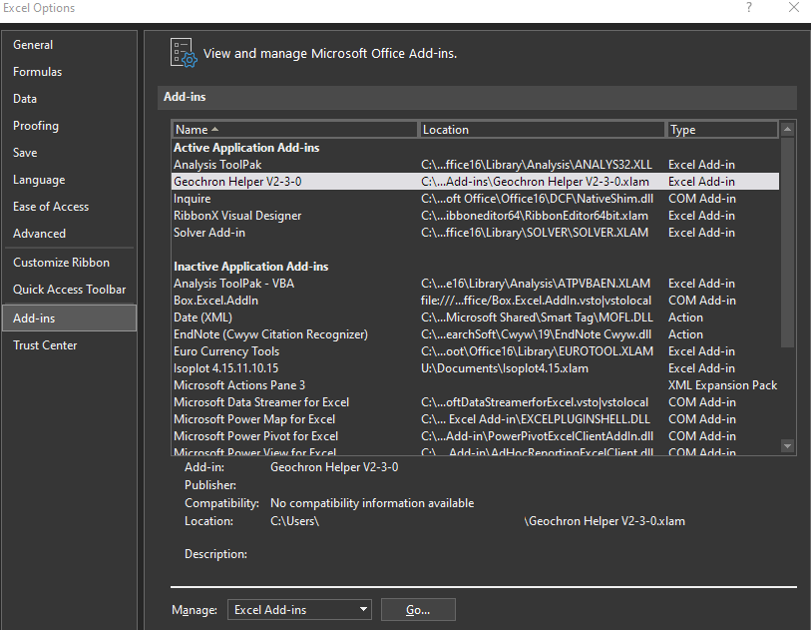

# LADR geochronology output arrangers

The *LADR geochronology outputs* section within *Geochronology Helper* is designed to be a dynamic and automated procedure that will prepare the CSV output from LADR for U–Pb, Rb–Sr, or Lu–Hf geochronology and elemental data in a user-friendly format that is suitable for easy interoperability with the IsoplotR{Vermeesch, 2018 #67}{Vermeesch, 2018 #67} (Vermeesch, 2018){Vermeesch, 2018 #67} GUI or your own codes in R, Julia, MATLAB etc.

Currently four procedure variants are coded, one for Lu–Hf, one for Rb–Sr, and two for U–Pb (Wetherill and Tera-Wasserburg variants). The menus provide options for a single CSV, multiple CSVs or a “Rho” variant for Lu–Hf and Rb–Sr.

The presence of quantified elemental data is dynamically accounted for. If no quantified elemental data is present the arranger will only rearrange the ratio data. The Wetherill and TW variants simply change the order of U/Pb and Pb/Pb ratios, and have different required ratios. Wetherill requires a form of 207/235, 207/206 and 206/238, while TW only require 238/206 and 207/206. The code can handle missing 206/238 or 238/206 so long as one is present by taking the inverse value.

Rb–Sr and Lu–Hf require one pair of ratios for either a normal or inverse isochron.

Upon selection of a procedure, it first calls a confirm procedure. The user a prompt to confirm the execution of the main procedure. If the user selects “No” this will end the procedure, if “Yes” the procedure will execute. This is to prevent accidentally running the wrong procedure

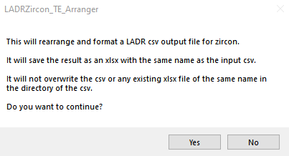

Once the main procedure is confirmed the user will be presented a series of dialogs, the total number is dependent on the first input. The first dialog asks the user to enter the number of standards used, this needs to be entered as a value between 1 & 5. At this point in time the procedure can manage up to five standards. It can be modified to handle more quite easily. The default value is 4.

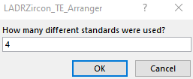

Up to four subsequent dialogs will prompt the user to enter the names of the standards used. These need to be entered as they appear in the filenames (original CSVs)—it is not case sensitive.

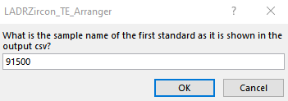

Beyond this point the procedure will run without redrawing or recalculating the screen until the last few steps where it freezes the top row and first three columns for each of the new sheets that are created. This will cause the screen to quickly redraw a couple of times, however, unlike the rest of the procedure this cannot be run with Excel’s application redrawing paused.

A message with time taken to complete is displayed upon completion of the procedure.

The procedure is optimised for performance and completes the following tasks:

* Creates new sheets
  + Geochronology Data – Unknowns
  + Geochronology Data – Standards
  + Elemental Data – Unknowns (if quantified elemental data present)
  + Elemental Data – Standards (if quantified elemental data present)
* Copies data from original csv sheets to the new sheets
* Dynamically determines variable for standards
* Dynamically determines ranges to copy
* Adds sequential numbers back to standards in the analysis column
  + These are removed in the logbook for data reduction in LADR
* Fixes sequential numbers for all analyses to format “000”
  + Corrects sorting for analyses
    - E.g. “unknown – 1” becomes “unknown – 001”
* Separates unknowns and standards
* Sorts sheets by *Analysis* column
* Writes additional and corrected headers to geochronology sheets
* Keeps original data in a separate sheet
* Freezes columns 1:3, row 1 of new sheets
* Makes headers bold
* Autofits columns based on header row
  + Autofits *AL#, Sample, Analysis* and *Comments* based on contents
* Saves as new workbook in original directory of CSV, will not overwrite original CSV or XLSX of same file name.
* Relevant to Lu–Hf and Rb–Sr:
  + Formats for easy interoperability with IsoplotR Rb–Sr and Lu–Hf “normal” and “inverse” input options
  + Two system approximation of rho IF signal precision
    - This approximation is numerically unstable and likely to give an unreliable result
* Relevant to U–Pb only:
* Adds formulas to calculate relative concordance for [06/38-07/06], [06/38-07/35], [07/35-07/06] and a log-ratio distance measure of concordance.
* Adds formulas to calculate ρ[07/35][06/38] and ρ[06/38][07/06] based on (Schmitz & Schoene, 2007)
  + [*only if data is signal precision level and rho was not output from LADR*]
* Formats *Geochronology* for easy interoperability with IsoplotR, U–Pb Concordia input format [07/35], [06/38], [07/06]

The only explicit error handling is when the file does not save due to a conflict with an already existing file of the same name or initial variables are not correctly set by the user.

Aside from this, errors should not occur unless the procedure is executed on a file that is not suitable. If they do, please note the error code and description, click on debug, screenshot the code, and finally send that information to me.

There is a batch processor available for multiple CSV files. Due to the nature of non-standardised file naming this will run on all CSV files in the host folder of the currently open and active workbook. It will call upon the single LADR processing procedure, requiring some input from the user for each file.

It is best to move all the files you want to process into a single folder. It will create a series of XLSX files with the same name as the CSV on which it is executed.

Errors will occur if this runs on non-LADR geochronology output CSV files as it will not be able to define the variables it uses, e.g., it will not be able to set the variable *AgeEst207Pb206PbCol* by finding the cell containing “207/206 Age”.

## Secondary standard corrections

If you need to apply a secondary standard correction you will need to manually add the required information and formulas to the sheets in the correct places. The generalised formula for doing so is (F4 will lock cell references of formulas in Excel):

# Graphical user interface, text, email Description automatically generatedLADR S isotope arranger

This procedure functions the same as the Rb–Sr and Lu–Hf variants but looks for different column headers and does not have a batch function.

Like all other procedures a confirmation dialog will appear at the start of both functionalities to prevent accidental execution.

# LADR Elemental arranger

This procedure functions the same as other LADR arrangers but only for elemental data. It will work on data with ratios as well, but only arrange the elemental data.

Like all other procedures a confirmation dialog will appear at the start of both functionalities to prevent accidental execution.

# Re–Os (QQQ pre-processing for iolite)

WARNING: This procedure is hard coded to not operate if more than 500 CSV files are present in the host folder.

This procedure alters csv headers and correct values for 187Os, adds calculations for 187Re/187Os, 187Os/187Re and a Re–Os age in Ma (column is done as Cn277 for iolite purposes).

Like all other procedures a confirmation dialog will appear at the start of both functionalities to prevent accidental execution.

I will revisit this functionality and documentation in future, the function will be deprecated if an alternative in LADR is available.

# GLITTER functionality

The functionality of this is based upon Ben’s Arranger for processing legacy GLITTER output CSV files. It has been updated to be slightly more flexible, correctly calculate rho and execute faster but is not fully optimised for performance. I am not planning to optimise further this as we (Uni Adelaide Earth Sciences) do not use GLITTER anymore.

There is a procedure to process an individual sheet that will run on the active workbook.

In addition, there is a batch processor that will operate on any CSV in the host folder of the currently active workbook. This will loop the individual procedure on each CSV saving them as new XLSX files. As with the LADR batch processor it is best to move all the files you want to process into a single folder. It will create a series of XLSX files with the same name as the CSV on which it is executed.

Like all other procedures a confirmation dialog will appear at the start of both functionalities to prevent accidental execution.

# Utilities

## Individual column sorter and text Clean

This is a very simple procedure that will sort each column on the currently active sheet separately. It is safe for use with data with headers (in the first row only) and will dynamically identify the ranges to sort and the range to clean of text.

It will work on non-contiguous ranges with respect to both columns and rows.

A confirmation procedure is called before the main procedure is executed to prevent accidentally running it. It is a good idea to save the workbook before executing this procedure of the add-in.

After confirmation from the user, the primary procedure will execute running the sort. A further confirmation dialog will appear after the sort has executed asking if the user wants to remove text values from row two and below. The user can leave text in these rows by clicking no on the dialog box. It will remain sorted at the bottom of each row.

It is primarily designed around preparation of data for KDE and MDS plotting within IsoplotR but is not limited to this.

## LADR error correlation workaround

WARNING: These procedures are hard coded to not operate if more than 500 CSV files are present in the host folder.

I STRONGLY recommend that you use the cross-platform PowerShell (Core) function I’ve written for this operation. It is available at <https://github.com/jarredclloyd/PowerShell_LADR_errorcorrelation_workaround>. The PowerShell version is much faster, more robust, and more stable.

If you insist, or otherwise cannot use the PowerShell function, ensure that at maximum 500 mass-spectrometer output CSV files are in the host folder then run the appropriate procedure.

These procedures are designed to replace specific header values as U and Pb values to enable accurate calculation of error correlations for Rb–Sr and Lu–Hf geochronometry ratios. This is currently a necessary workaround for LADR, and hopefully resolved in a future version. It will not overwrite the original files (makes a copy) but will take some time to run.

# References

Microsoft, 2020, March 09. *Excel Visual Basic for Applications (VBA) reference*. Retrieved from Microsoft Docs: <https://docs.microsoft.com/en-us/office/vba/api/overview/excel>

Schmitz, M., & Schoene, B. (2007). Derivation of isotopes ratios, errors, and error correlations for U–Pb geochronology using 205Pb-235U-(233U)-spiked isotope dilution thermal ionization mass spectrometric data. *Geochemistry, Geophysics, Geosystems, 8:* <https://doi.org/10.1029/2006GC001492>

Vermeesch, P. (2018). IsoplotR: a free and open toolbox for geochronology. *Geoscience Frontiers, 9*(5), 1479-1493: <https://doi.org/10.1016/j.gsf.2018.04.001>